 

|  |
| --- |
| FPT-aptech computer education |
| eProject Document |
| Recruitment Process System |
|  |
| |  |  | | --- | --- | |  | | | **Group Member** | Hoang Do Phu - C00473 - 1689  Tung Trinh Minh - C00194 - 6196  Luong Bach Van - A03593 - 6109 | | **Instructor** | Vinh Duong Le | | **Batch** | C0812L | | **Semester** | 4 | |
|  |

|  |
| --- |
| - Hanoi, 4/2012 - |

Contents

1. Introduction 3

2. Problem Definition 3

2.1. Problem Abstraction 3

2.2. The Current System 3

2.3. The Proposed System 3

2.4. Boundaries of the System 6

2.5. Development Environment 6

3. Requirements and Business Flow 7

3.1. Customer Requirement Specification 7

3.2. Activity Diagram 7

3.3. Use Case Diagram 10

3.4. Use Case Specification 14

*4.* Design 42

4.1. System Architecture 42

4.2. Class Diagram 43

4.3. Entity Relationship Diagram 46

4.4. Database Design 47

5. System Prototype 48

6. Management and Project Planning 51

6.1. Management Approach 51

6.2. Task Sheet 51

7. Screenshots 53

8. Coding Convention 57

# Introduction

This report includes analyzes, surveys, how to solve problems, design … about “Recruitment Process System”.

Starting from the requirements of customers, we analyzed to design some diagrams that would be supported for our team when coding.

# Problem Definition

## Problem Abstraction

This project is aimed at developing a web-based and central Recruitment Process System for the HR Group for a company. Some features of this system will be creating vacancies, storing Applicants data, Interview process initiation, Scheduling Interviews, Storing Interview results for the applicant and finally Hiring of the applicant. Reports may be required to be generated for the use of HR group.

## The Current System

There are HR group who will create vacancies, create applicants (persons applying for a vacancy), initiate interviews and close vacancy. There are interviewers who will be intimated about the interview schedule and finally enters the result.

## The Proposed System

The requirements are as follows:

1. **Generic:**
   1. Login to the system through the first page of the application – *the welcome message should display the Name and Employee number of the person.*
   2. Change the password after login to the application
   3. See his/her details and change it.
   4. Help from the system
2. **HR group:**
   1. Should be able to create a new vacancy.
   2. Should be able to change any of the editable details for the vacancy.
   3. Should be able to create a new applicant.
   4. Should be able to change any of the editable details for the applicant.
   5. Should be able to search on Applicant Number and Vacancy Number.
   6. Attach an applicant to a vacancy - *The relationship between applicant and vacancy should be many:many.*
   7. Should be able to schedule the interview and enter details of the interviewer and date/time.
   8. Should be able to postpone or remove the interview.

.

1. **Interviewer:**
   1. Should be able to view all interviews scheduled to be taken.
   2. Should be able to view the details of the applicants details
   3. Should be able to view the details of the vacancy.
   4. Should be able to search on Interview Date, Applicant Number and Vacancy Number.
   5. Should have the access to change the Interview details – Date/Time, Status (Selected/Rejected).
2. **Other details:**
   1. The vacancy should have the following details:
      1. System should generate a Vacancy number sequentially. *This should be unique and cannot be changed later on.*
      2. Date of the creation of the vacancy should default as today – *This cannot be changed later on.*
      3. Status of the Vacancy – Open/Close/Suspended. *This should default as Open but can be changed later by HR.*
      4. Title of the Vacancy (like Java Developer etc.)
      5. Number of job opening under that vacancy (like 5 numbers of Java Developers required). *Once all these job openings are filled i.e. 5 people are hired, the vacancy should close itself.*
      6. Department in the company – *this should come from a drop-down box which have the Department list.*
      7. Date by which the vacancy should be fulfilled/gets closed – *this can be left blank otherwise the vacancy will close on that day by default.*
      8. List of all the applicants already ‘Selected’ for a job openings in the vacancy.
   2. Applicant details should have the following:
      1. System should generate an Applicant number sequentially. *This should be unique and cannot be changed later on.*
      2. Date of the creation of the applicant should default as today – *This cannot be changed later on.*
      3. Status of the Applicant – Not in Process/In Process/Hired/Banned.
      4. The Applicant Status should default as ‘Not in Process’ on creation of the applicant but as soon as a single vacancy is attached, this should default as ‘In Process’. No more vacancy can be attached to the applicant, if the status is either ‘Hired’ or ‘Banned’ - *The status can be changed manually by HR Group.*
   3. Applicant-Vacancy data should have the following:
      1. This should display the Applicant Number and Name.
      2. This should display the Vacancy Number and Title
      3. Display the date on this the Applicant is attached to the vacancy
      4. Status of the Applicant/Vacancy – Interview Scheduled/Selected/Rejected/Not Required.
      5. Checkbox stating – ‘Schedule Interview’. This should open the page with following details.
         1. Display the Employee Number of the Interviewer – *The interviewer should be from the same department.*
         2. Display the Name of the Interviewer – this should default if the number is selected.
         3. Display the date of the scheduled interview – *Date should only be in future.*
         4. Display the Start and End time of the scheduled interview – *Date/Time of the interview for the same Interviewer should not conflict with any other interview previously scheduled for the interviewer/applicant.*
   4. As soon as all the number of job openings is filled, the vacancy status should change to ‘Close’ by default.
   5. HR group should not be able to attach an applicant to vacancy if the status of the Vacancy is ‘Close/Suspended’.
   6. Once closed, a vacancy can not be reopened or suspended in any case.
   7. If Open, the status of the vacancy can be changed to ‘Close’ or ‘Suspended’ by the HR.
   8. If ‘Suspended’, the status of the vacancy can be changed to ‘Close’ or ‘Open’ by the HR.
   9. Once the status of the Applicant-Vacancy becomes ‘Selected’, the status of the Applicant should change by default to ‘Hired’.
   10. The required security needs to be implemented.
   11. HR group is the Employees from ‘HRD’ department.

## Boundaries of the System

The system will be used by employees of the company:

* Admin
* HR Group
* Interviewer

## Development Environment

|  |  |  |
| --- | --- | --- |
|  | **Server** | **Client** |
| Hardware | * Ram 512 MB or larger  * CPU 2.0 Ghz or larger  * HDD 80 GB or larger  * Connect to internet | * Ram 128 Mb or larger  * CPU 266 MHZ or larger  * Connect to internet |
| Software | * Windows Server 2000 or later  * SQL Server 2005 or later  * IIS 6 or later | * Internet Explorer  * Firefox  * Chrome  * Safari |

*Developer tools*

* Microsoft Windows 2000 SP4 or higher
* Net Bean 6.9 or higher
* Microsoft SQL Server 2005 Standard Edition or higher
* j2sdk1.4.1_02 (or later)
* Microsoft Office XP
* Microsoft Internet Explorer 7.0
* Adobe Dreamweaver CS5

# Requirements and Business Flow

## Customer Requirement Specification

The customer requirement contains:

1. For HR group:
   * Creating vacancies
   * Storing Applicants data
   * Interview process initiation
   * Scheduling interviews
   * Close vacancy
   * View reports
2. For Interviewer:
   * Receive interview schedule
   * Enter the result

## Activity Diagram

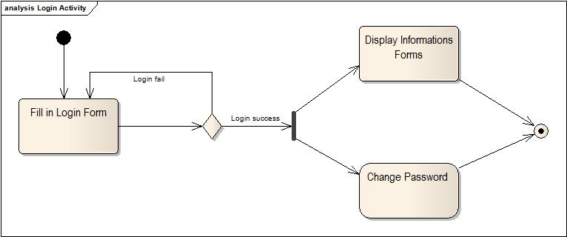

Figure 3.2.1 Login Diagram

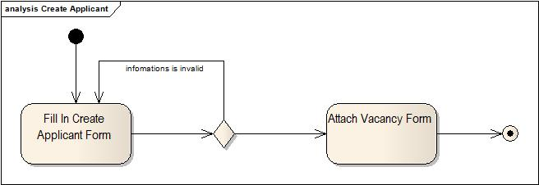

Figure 3.2.2 Create Applicant Diagram

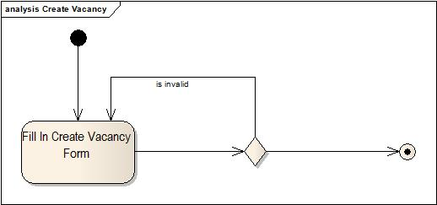

Figure 3.2.3 Create Vacancy Diagram

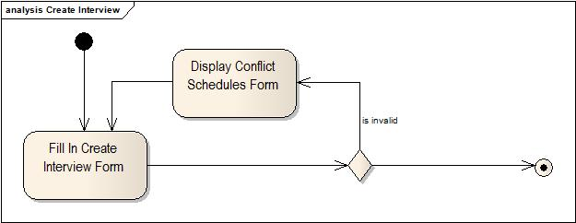

Figure 3.2.4 Create Interview Diagram

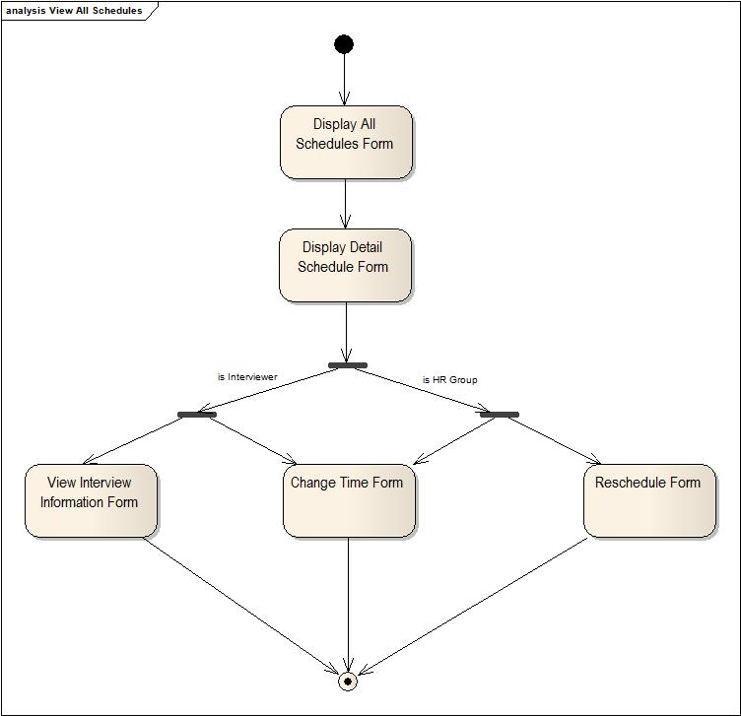

Figure 3.2.5 View All Schedules Diagram

## Use Case Diagram

## Recruitment Process System.jpg

Figure 3.3.1 Recruitment Process System Diagram

With our ability and the time be limited, we only focus on exploiting the functions that affect the system and emphasis on two main actors of the system. There are HR Group & Interviewer, the following are the functions that we will deploy:

* Manage Applicants
* Manage Vacancies
* Manage Interview Schedules
* Login
* View Personal Information
* Change Password
* View All Reports

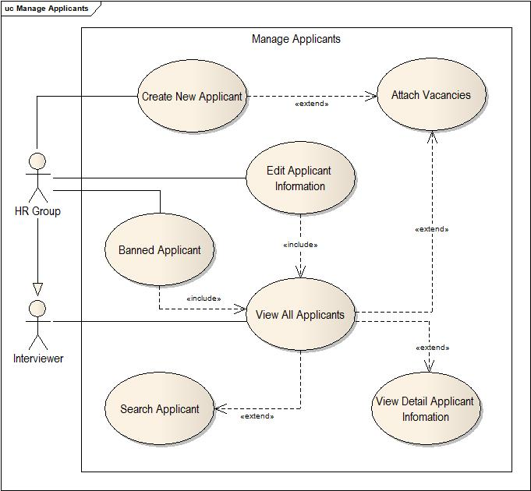

Figure 3.3.2 Manage Applicants Diagram

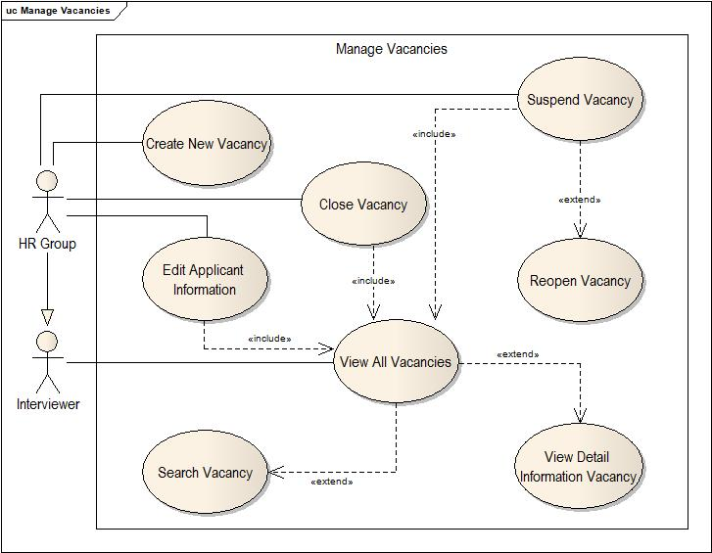

Figure 3.3.3 Manage Vacancies

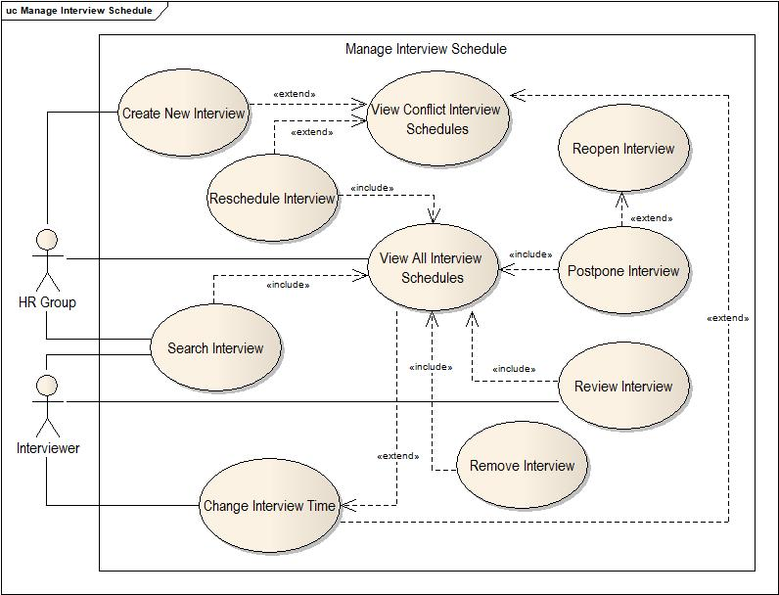

Figure 3.3.4 Manage Interview Schedules Diagram

## Use Case Specification

|  |  |  |  |  |
| --- | --- | --- | --- | --- |
| **USE CASE SPECIFICATION** | | | | |
| **Use-case No.** | UC001 | **Use-case Version** | | 1.0 |
| **Use-case Name** | Login | | | |
| **Author** | Hoang Do Phu | | | |
| **Date** |  | **Priority** | Low | |
| **Actor:**   * HR Group * Interviewer * Admin   **Summary:**  This use case allows users to login into the system  **Goal:**   * Login into the system   **Triggers**  None  **Preconditions:**  None  **Post Conditions:**   * Store account’s data into session   **Main Success Scenario:**   * Validate user name and password * Return notification if logging failed   **Alternative Scenario:**  None  **Exceptions:**   * User name or password invalid   **Relationships:**   * All of other use cases in “Recruitment Process System Diagram”   **Business Rules:**   * Password will be validate by MD5 code to compare with the password in database | | | | |

|  |  |  |  |  |
| --- | --- | --- | --- | --- |
| **USE CASE SPECIFICATION** | | | | |
| **Use-case No.** | UC002 | **Use-case Version** | | 1.0 |
| **Use-case Name** | View Personal Information | | | |
| **Author** | Hoang Do Phu | | | |
| **Date** |  | **Priority** | Low | |
| **Actor:**   * HR Group * Interviewer * Admin   **Summary:**  This use case will be display personal information of the account that is logging  **Goal:**   * Display all information that relate with the logging account   **Triggers**   * After login process is successful immediately   **Preconditions:**   * Login success   **Post Conditions:**  None  **Main Success Scenario:**   * Get information of the account into session * Get all personal information into database by the account’s information     **Alternative Scenario:**  None  **Exceptions:**  None  **Relationships:**  None  **Business Rules:**  None | | | | |

|  |  |  |  |  |
| --- | --- | --- | --- | --- |
| **USE CASE SPECIFICATION** | | | | |
| **Use-case No.** | UC003 | **Use-case Version** | | 1.0 |
| **Use-case Name** | View All Reports | | | |
| **Author** |  | | | |
| **Date** |  | **Priority** | Low | |
| **Actor:**   * HR Group   **Summary:**  This use case will be display some charts to statistic some information  **Goal:**   * Statistic some information   **Triggers**  None  **Preconditions:**   * Login success   **Post Conditions:**   * Information should be displayed in chart form   **Main Success Scenario:**   * Get information into database     **Alternative Scenario:**  None  **Exceptions:**  None  **Relationships:**  None  **Business Rules:**   * Information should be returned in List<Generic> type | | | | |

|  |  |  |  |  |
| --- | --- | --- | --- | --- |
| **USE CASE SPECIFICATION** | | | | |
| **Use-case No.** | UC004 | **Use-case Version** | | 1.0 |
| **Use-case Name** | Create New Applicant | | | |
| **Author** | Hoang Do Phu | | | |
| **Date** |  | **Priority** | High | |
| **Actor:**   * HR Group   **Summary:**   * This use case will allow user to create a new applicant   **Goal:**   * Create a new applicant   **Triggers**  None  **Preconditions:**   * Login success   **Post Conditions:**   * Validate form * Check email is existed   **Main Success Scenario:**   * Enter information to form * Reenter if the form has invalid information * Display information when success     **Alternative Scenario:**  None  **Exceptions:**   * Invalid information   **Relationships:**   * Could be attach vacancies for new applicant   **Business Rules:**   * The email should be unique | | | | |

|  |  |  |  |  |
| --- | --- | --- | --- | --- |
| **USE CASE SPECIFICATION** | | | | |
| **Use-case No.** | UC005 | **Use-case Version** | | 1.0 |
| **Use-case Name** | Attach Vacancies | | | |
| **Author** | Hoang Do Phu | | | |
| **Date** |  | **Priority** | High | |
| **Actor:**   * HR Group   **Summary:**   * This use case allow user to attach some vacancies for the applicants   **Goal:**   * Attach some vacancies for the applicants   **Triggers**  None  **Preconditions:**   * Login success * The vacancy’s information * The applicant’s information   **Post Conditions:**  None  **Main Success Scenario:**   * Select the applicant * Display all the applicant’s vacancy if the applicant had * Display all the available vacancies * Add or remove the vacancies for the applicant     **Alternative Scenario:**  None  **Exceptions:**  None  **Relationships:**  None  **Business Rules:**   * Display only the vacancies that is opening * Display only the applicant that not hired or banned * Could be display the interview schedule if the applicant registered | | | | |

|  |  |  |  |  |
| --- | --- | --- | --- | --- |
| **USE CASE SPECIFICATION** | | | | |
| **Use-case No.** | UC006 | **Use-case Version** | | 1.0 |
| **Use-case Name** | Edit Applicant Information | | | |
| **Author** | Hoang Do Phu | | | |
| **Date** |  | **Priority** | Normal | |
| **Actor:**   * HR Group   **Summary:**   * This use case will be updated applicant information   **Goal:**   * Update the applicant information   **Triggers**   * Selected the applicant   **Preconditions:**   * Login success * Must be have the applicant ID   **Post Conditions:**   * Validate form   **Main Success Scenario:**   * Get applicant ID from query string * Fill all the applicant information to the form * Validate form * Return notification when success     **Alternative Scenario:**  None  **Exceptions:**   * The applicant could be not found if the query string is invalid or the applicant information is not existed in database   **Relationships:**  None  **Business Rules:**  None | | | | |

|  |  |  |  |  |
| --- | --- | --- | --- | --- |
| **USE CASE SPECIFICATION** | | | | |
| **Use-case No.** | UC007 | **Use-case Version** | | 1.0 |
| **Use-case Name** | View All Applicants | | | |
| **Author** | Hoang Do Phu | | | |
| **Date** |  | **Priority** | High | |
| **Actor:**   * HR Group * Interviewer   **Summary:**   * Display list of applicants   **Goal:**   * Display list of applicants   **Triggers**  None  **Preconditions:**   * Login success   **Post Conditions:**  None  **Main Success Scenario:**   * Get all applicant’s information from database   **Alternative Scenario:**  None  **Exceptions:**  None  **Relationships:**   * Search applicant * Banned applicant * Edit applicant * View detail applicant information * Attach applicant   **Business Rules:**  None | | | | |

|  |  |  |  |  |
| --- | --- | --- | --- | --- |
| **USE CASE SPECIFICATION** | | | | |
| **Use-case No.** | UC008 | **Use-case Version** | | 1.0 |
| **Use-case Name** | Banned Applicant | | | |
| **Author** | Hoang Do Phu | | | |
| **Date** |  | **Priority** | High | |
| **Actor:**   * HR Group   **Summary:**   * This use case allow user to banned an applicant was hired before   **Goal:**   * Banned an applicant   **Triggers**   * The applicant was hired before   **Preconditions:**   * Login success * The applicant was hired   **Post Conditions:**  None  **Main Success Scenario:**   * Banned an applicant * Display confirm for user * Display notification when done     **Alternative Scenario:**  None  **Exceptions:**  None  **Relationships:**  None  **Business Rules:**   * Change the applicant’s status | | | | |

|  |  |  |  |  |
| --- | --- | --- | --- | --- |
| **USE CASE SPECIFICATION** | | | | |
| **Use-case No.** | UC009 | **Use-case Version** | | 1.0 |
| **Use-case Name** | Search Applicant | | | |
| **Author** | Luong Bach Van | | | |
| **Date** |  | **Priority** | Normal | |
| **Actor:**   * HR Group * Inerviewer   **Summary:**   * This use case will be search applicants with related information   **Goal:**   * Display all applicants with searched information   **Triggers**  None  **Preconditions:**   * Login success   **Post Conditions:**  None  **Main Success Scenario:**   * Get information from search form * Display all applicants with that information * Display a message for the search’s result     **Alternative Scenario:**  None  **Exceptions:**  None  **Relationships:**  None  **Business Rules:**  None | | | | |

|  |  |  |  |  |
| --- | --- | --- | --- | --- |
| **USE CASE SPECIFICATION** | | | | |
| **Use-case No.** | UC010 | **Use-case Version** | | 1.0 |
| **Use-case Name** | View Detail Applicant Information | | | |
| **Author** | Hoang Do Phu | | | |
| **Date** |  | **Priority** | Normal | |
| **Actor:**   * HR Group * Interviewer   **Summary:**   * This use case will be displayed the detail applicant information   **Goal:**   * Display the detail applicant information   **Triggers**   * An applicant was selected   **Preconditions:**   * Login success * View all applicants   **Post Conditions:**   * Must be had applicant ID in query string   **Main Success Scenario:**   * Get applicant ID from query string * Display the applicant’s information * Display all vacancies of the applicant if they are existed     **Alternative Scenario:**  None  **Exceptions:**   * The applicant could be not found if the query string is invalid or the applicant information is not existed in database   **Relationships:**   * View detail vacancy’s information * View interview schedule if the applicant registered before   **Business Rules:**  None | | | | |

|  |  |  |  |  |
| --- | --- | --- | --- | --- |
| **USE CASE SPECIFICATION** | | | | |
| **Use-case No.** | UC011 | **Use-case Version** | | 1.0 |
| **Use-case Name** | Create New Vacancy | | | |
| **Author** | Tung Trinh Minh | | | |
| **Date** |  | **Priority** | High | |
| **Actor:**   * HR Group   **Summary:**   * This use case will allow user to create a new vacancy   **Goal:**   * Create a new vacancy   **Triggers**  None  **Preconditions:**   * Login success   **Post Conditions:**   * Validate form   **Main Success Scenario:**   * Enter information to form * Reenter if the form has invalid information * Display information when success     **Alternative Scenario:**  None  **Exceptions:**   * Invalid information   **Relationships:**  None  **Business Rules:**  None | | | | |

|  |  |  |  |  |
| --- | --- | --- | --- | --- |
| **USE CASE SPECIFICATION** | | | | |
| **Use-case No.** | UC012 | **Use-case Version** | | 1.0 |
| **Use-case Name** | Edit Vacancy Information | | | |
| **Author** | Tung Trinh Minh | | | |
| **Date** |  | **Priority** | Normal | |
| **Actor:**   * HR Group   **Summary:**   * This use case will be updated vacancy information   **Goal:**   * Update the vacancy information   **Triggers**   * Selected the vacancy   **Preconditions:**   * Login success * Must be have the vacancy ID   **Post Conditions:**   * Validate form   **Main Success Scenario:**   * Get vacancy ID from query string * Fill all the vacancy information to the form * Validate form * Return notification when success     **Alternative Scenario:**  None  **Exceptions:**   * The vacancy could be not found if the query string is invalid or the vacancy information is not existed in database   **Relationships:**  None  **Business Rules:**  None | | | | |

|  |  |  |  |  |
| --- | --- | --- | --- | --- |
| **USE CASE SPECIFICATION** | | | | |
| **Use-case No.** | UC013 | **Use-case Version** | | 1.0 |
| **Use-case Name** | View All Vacancies | | | |
| **Author** | Luong Bach Van | | | |
| **Date** |  | **Priority** | High | |
| **Actor:**   * HR Group * Interviewer   **Summary:**   * Display list of vacancies   **Goal:**   * Display list of vacancies   **Triggers**  None  **Preconditions:**   * Login success   **Post Conditions:**  None  **Main Success Scenario:**   * Get all vacancy’s information from database   **Alternative Scenario:**  None  **Exceptions:**  None  **Relationships:**   * Search vacancy * Suspend vacancy * Reopen vacancy * Close vacancy * Edit vacancy * View detail vacancy information   **Business Rules:**  None | | | | |

|  |  |  |  |  |
| --- | --- | --- | --- | --- |
| **USE CASE SPECIFICATION** | | | | |
| **Use-case No.** | UC014 | **Use-case Version** | | 1.0 |
| **Use-case Name** | Search Vacancy | | | |
| **Author** | Luong Bach Van | | | |
| **Date** |  | **Priority** | Normal | |
| **Actor:**   * HR Group * Interviewer   **Summary:**   * This use case will be search vacancies with related information   **Goal:**   * Display all vacancies with searched information   **Triggers**  None  **Preconditions:**   * Login success * View all vacancies   **Post Conditions:**  None  **Main Success Scenario:**   * Get information from search form * Display all vacancies with that information * Display a message for the search’s result     **Alternative Scenario:**  None  **Exceptions:**  None  **Relationships:**  None  **Business Rules:**  None | | | | |

|  |  |  |  |  |
| --- | --- | --- | --- | --- |
| **USE CASE SPECIFICATION** | | | | |
| **Use-case No.** | UC015 | **Use-case Version** | | 1.0 |
| **Use-case Name** | View Detail Vacancy Information | | | |
| **Author** | Hoang Do Phu | | | |
| **Date** |  | **Priority** | Normal | |
| **Actor:**   * HR Group * Interviewer   **Summary:**   * This use case will be displayed the detail vacancy information   **Goal:**   * Display the detail vacancy information   **Triggers**   * An vacancy was selected   **Preconditions:**   * Login success * View all vacancies   **Post Conditions:**   * Must be had vacancy ID in query string   **Main Success Scenario:**   * Get vacancy ID from query string * Display the vacancy ‘s information * Display all applicants of the vacancy if they are existed     **Alternative Scenario:**  None  **Exceptions:**   * The vacancy could be not found if the query string is invalid or the vacancy information is not existed in database   **Relationships:**   * View detail applicant’s information * View interview schedule if the applicant registered before   **Business Rules:**  None | | | | |

|  |  |  |  |  |
| --- | --- | --- | --- | --- |
| **USE CASE SPECIFICATION** | | | | |
| **Use-case No.** | UC016 | **Use-case Version** | | 1.0 |
| **Use-case Name** | Close Vacancy | | | |
| **Author** | Hoang Do Phu | | | |
| **Date** |  | **Priority** | High | |
| **Actor:**   * HR Group   **Summary:**   * This use case allows user close a vacancy   **Goal:**   * Close a vacancy   **Triggers**   * All the number of job openings is filled   **Preconditions:**   * Login success * View all vacancies   **Post Conditions:**  None  **Main Success Scenario:**   * Close a vacancy * Display confirm for user * Display notification when done     **Alternative Scenario:**  None  **Exceptions:**  None  **Relationships:**  None  **Business Rules:**  None | | | | |

|  |  |  |  |  |
| --- | --- | --- | --- | --- |
| **USE CASE SPECIFICATION** | | | | |
| **Use-case No.** | UC017 | **Use-case Version** | | 1.0 |
| **Use-case Name** | Suspend Vacancy | | | |
| **Author** | Hoang Do Phu | | | |
| **Date** |  | **Priority** | High | |
| **Actor:**   * HR Group   **Summary:**   * This use case allows user suspend a vacancy   **Goal:**   * Suspend a vacancy   **Triggers**  None  **Preconditions:**   * Login success * View all vacancies   **Post Conditions:**  None  **Main Success Scenario:**   * Suspend a vacancy * Display confirm for user * Display notification when done     **Alternative Scenario:**  None  **Exceptions:**  None  **Relationships:**  None  **Business Rules:**  None | | | | |

|  |  |  |  |  |
| --- | --- | --- | --- | --- |
| **USE CASE SPECIFICATION** | | | | |
| **Use-case No.** | UC018 | **Use-case Version** | | 1.0 |
| **Use-case Name** | Reopen Vacancy | | | |
| **Author** | Hoang Do Phu | | | |
| **Date** |  | **Priority** | High | |
| **Actor:**   * HR Group   **Summary:**   * This use case allows user reopen a vacancy   **Goal:**   * Reopen a vacancy   **Triggers**   * The vacancy was suspended before   **Preconditions:**   * Login success * View all vacancies   **Post Conditions:**  None  **Main Success Scenario:**   * Reopen a vacancy * Display confirm for user * Display notification when done     **Alternative Scenario:**  None  **Exceptions:**  None  **Relationships:**  None  **Business Rules:**  None | | | | |

|  |  |  |  |  |
| --- | --- | --- | --- | --- |
| **USE CASE SPECIFICATION** | | | | |
| **Use-case No.** | UC019 | **Use-case Version** | | 1.0 |
| **Use-case Name** | Create New Interview | | | |
| **Author** | Hoang Do Phu | | | |
| **Date** |  | **Priority** | High | |
| **Actor:**   * HR Group   **Summary:**   * This use case will allow user to create a new interview   **Goal:**   * Create a new interview   **Triggers**  None  **Preconditions:**   * Login success   **Post Conditions:**   * Validate form   **Main Success Scenario:**   * Enter information to form * Reenter if the form has invalid information * Display information when success     **Alternative Scenario:**  None  **Exceptions:**   * Invalid information   **Relationships:**  None  **Business Rules:**  None | | | | |

|  |  |  |  |  |
| --- | --- | --- | --- | --- |
| **USE CASE SPECIFICATION** | | | | |
| **Use-case No.** | UC020 | **Use-case Version** | | 1.0 |
| **Use-case Name** | Change Interview’s Time | | | |
| **Author** | Hoang Do Phu | | | |
| **Date** |  | **Priority** | High | |
| **Actor:**   * HR Group * Interviewer   **Summary:**   * This use case will be updated interview information   **Goal:**   * Update the interview information   **Triggers**   * Selected the interview * View all interview schedules   **Preconditions:**   * Login success * Must be have the interview ID and type   **Post Conditions:**   * Validate form   **Main Success Scenario:**   * Get interview ID from query string * Fill all the vacancy information to the form * Validate form * Return notification when success     **Alternative Scenario:**  None  **Exceptions:**   * The interview could be not found if the query string is invalid or the interview information is not existed in database   **Relationships:**  None  **Business Rules:**  None | | | | |

|  |  |  |  |  |
| --- | --- | --- | --- | --- |
| **USE CASE SPECIFICATION** | | | | |
| **Use-case No.** | UC021 | **Use-case Version** | | 1.0 |
| **Use-case Name** | Reschedule Interview | | | |
| **Author** | Hoang Do Phu | | | |
| **Date** |  | **Priority** | High | |
| **Actor:**   * HR Group   **Summary:**   * This use case will be updated interview information   **Goal:**   * Update the interview information   **Triggers**   * Selected the interview * View all interview schedules   **Preconditions:**   * Login success * Must be have the interview ID and type   **Post Conditions:**   * Validate form   **Main Success Scenario:**   * Get interview ID from query string * Fill all the vacancy information to the form * Validate form * Return notification when success     **Alternative Scenario:**  None  **Exceptions:**   * The interview could be not found if the query string is invalid or the interview information is not existed in database   **Relationships:**  None  **Business Rules:**  None | | | | |

|  |  |  |  |  |
| --- | --- | --- | --- | --- |
| **USE CASE SPECIFICATION** | | | | |
| **Use-case No.** | UC022 | **Use-case Version** | | 1.0 |
| **Use-case Name** | View Conflict Interview Schedules | | | |
| **Author** | Hoang Do Phu | | | |
| **Date** |  | **Priority** | High | |
| **Actor:**   * HR Group   **Summary:**   * This use case will be displayed all interview schedules are conflicted   **Goal:**   * Display conflicted schedules   **Triggers**   * The interview schedule is conflict with other schedule that has been created before   **Preconditions:**   * Login success   **Post Conditions:**   * The conflicted interview ID   **Main Success Scenario:**   * Get conflicted interview ID * Get all interview schedules was conflicted * Display notification warning for user     **Alternative Scenario:**  None  **Exceptions:**  None  **Relationships:**  None  **Business Rules:**  None | | | | |

|  |  |  |  |  |
| --- | --- | --- | --- | --- |
| **USE CASE SPECIFICATION** | | | | |
| **Use-case No.** | UC023 | **Use-case Version** | | 1.0 |
| **Use-case Name** | Search Interview | | | |
| **Author** | Hoang Do Phu | | | |
| **Date** |  | **Priority** | Normal | |
| **Actor:**   * HR Group * Interviewer   **Summary:**   * This use case will be search interviews with related information   **Goal:**   * Display all interviews with searched information   **Triggers**  None  **Preconditions:**   * Login success * View all interview schedules   **Post Conditions:**  None  **Main Success Scenario:**   * Get information from search form * Display all interviews with that information * Display a message for the search’s result     **Alternative Scenario:**  None  **Exceptions:**  None  **Relationships:**  None  **Business Rules:**  None | | | | |

|  |  |  |  |  |
| --- | --- | --- | --- | --- |
| **USE CASE SPECIFICATION** | | | | |
| **Use-case No.** | UC024 | **Use-case Version** | | 1.0 |
| **Use-case Name** | View All Interview Schedules | | | |
| **Author** | Hoang Do Phu | | | |
| **Date** |  | **Priority** | High | |
| **Actor:**   * HR Group * Interviewer   **Summary:**   * Display list of interviews   **Goal:**   * Display list of interviews   **Triggers**  None  **Preconditions:**   * Login success   **Post Conditions:**  None  **Main Success Scenario:**   * Get all interview’s information from database   **Alternative Scenario:**  None  **Exceptions:**  None  **Relationships:**   * Search interview * Postpone interview * Reopen interview * Remove interview * Edit interview * Review interview * Change Interview Time * Reschedule Interview   **Business Rules:**  None | | | | |

|  |  |  |  |  |
| --- | --- | --- | --- | --- |
| **USE CASE SPECIFICATION** | | | | |
| **Use-case No.** | UC025 | **Use-case Version** | | 1.0 |
| **Use-case Name** | Remove Interview | | | |
| **Author** | Hoang Do Phu | | | |
| **Date** |  | **Priority** | High | |
| **Actor:**   * HR Group   **Summary:**   * This use case allows user remove an interview   **Goal:**   * Remove an interview   **Triggers**   * This interview has been reviewed   **Preconditions:**   * Login success * View all interviews   **Post Conditions:**  None  **Main Success Scenario:**   * Remove an interview * Display confirm for user * Display notification when done     **Alternative Scenario:**  None  **Exceptions:**  None  **Relationships:**  None  **Business Rules:**  None | | | | |

|  |  |  |  |  |
| --- | --- | --- | --- | --- |
| **USE CASE SPECIFICATION** | | | | |
| **Use-case No.** | UC026 | **Use-case Version** | | 1.0 |
| **Use-case Name** | Postpone Interview | | | |
| **Author** | Hoang Do Phu | | | |
| **Date** |  | **Priority** | High | |
| **Actor:**   * HR Group   **Summary:**   * This use case allows user postpone an interview   **Goal:**   * Postpone an interview   **Triggers**  None  **Preconditions:**   * Login success * View all interviews   **Post Conditions:**  None  **Main Success Scenario:**   * Postpone an interview * Display confirm for user * Display notification when done     **Alternative Scenario:**  None  **Exceptions:**  None  **Relationships:**  None  **Business Rules:**  None | | | | |

|  |  |  |  |  |
| --- | --- | --- | --- | --- |
| **USE CASE SPECIFICATION** | | | | |
| **Use-case No.** | UC027 | **Use-case Version** | | 1.0 |
| **Use-case Name** | Reopen Interview | | | |
| **Author** | Hoang Do Phu | | | |
| **Date** |  | **Priority** | High | |
| **Actor:**   * HR Group   **Summary:**   * This use case allows user reopen an interview   **Goal:**   * Reopen an interview   **Triggers**   * The interview was postponed before   **Preconditions:**   * Login success * View all interviews   **Post Conditions:**  None  **Main Success Scenario:**   * Reopen an interview * Display confirm for user * Display notification when done     **Alternative Scenario:**  None  **Exceptions:**  None  **Relationships:**  None  **Business Rules:**  None | | | | |

|  |  |  |  |  |
| --- | --- | --- | --- | --- |
| **USE CASE SPECIFICATION** | | | | |
| **Use-case No.** | UC028 | **Use-case Version** | | 1.0 |
| **Use-case Name** | Review Interview | | | |
| **Author** | Hoang Do Phu | | | |
| **Date** |  | **Priority** | High | |
| **Actor:**   * Interviewer   **Summary:**   * This use case allows user to review the interview   **Goal:**   * Review the interview   **Triggers**  None  **Preconditions:**   * Login success * The interview schedule must be selected by interviewer   **Post Conditions:**  None  **Main Success Scenario:**   * Display review form * Select status for the interview schedule * Display notification when done     **Alternative Scenario:**  None  **Exceptions:**  None  **Relationships:**  None  **Business Rules:**   * Must be check number requirement of the vacancy if the interview schedule has been selected * Change status for all of interview schedule is “not required” if all the number of job openings is filled | | | | |

# Design

## System Architecture

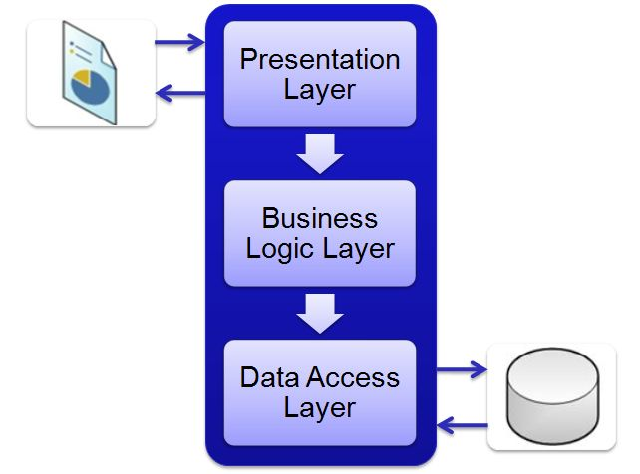

Figure 4.1 System Architecture Diagram

## Class Diagram

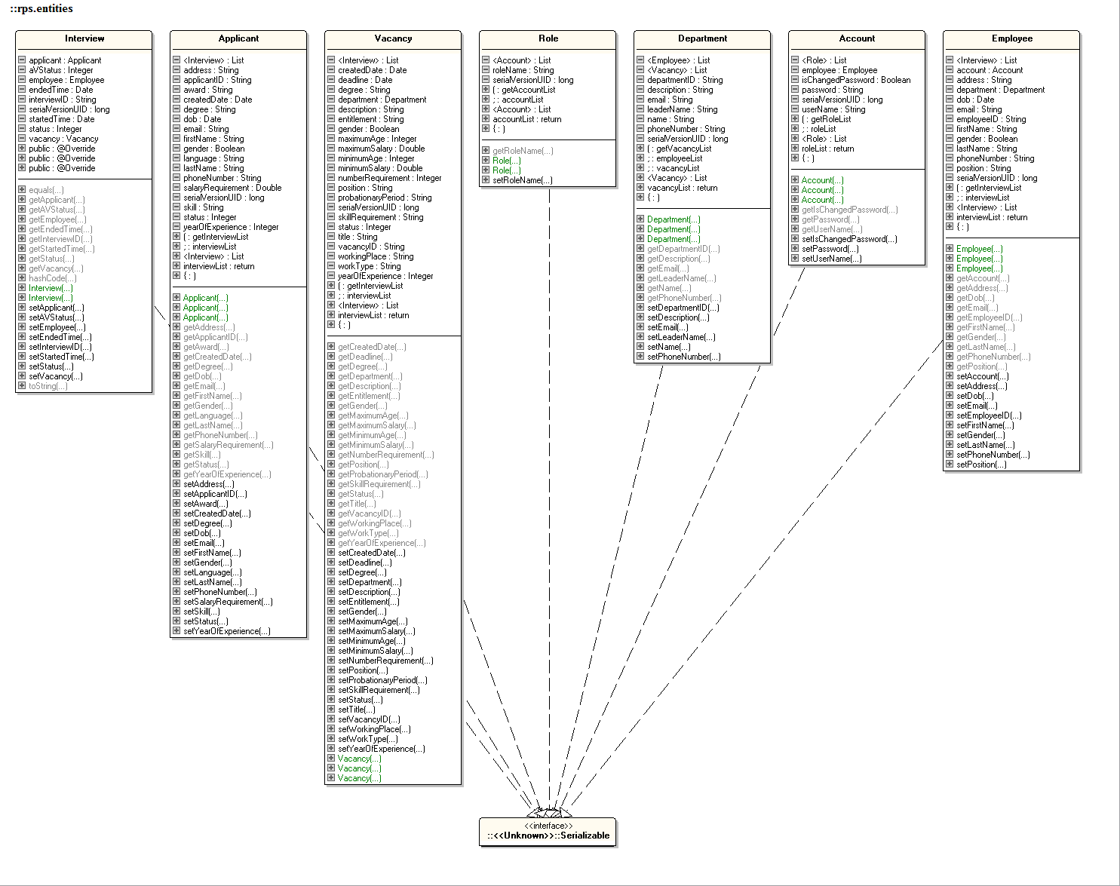

Figure 4.2.1 Entities Class Diagram

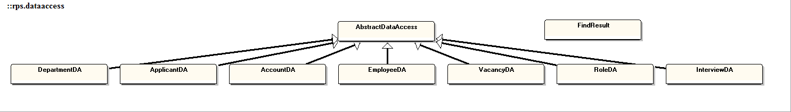

Figure 4.2.2 Data Access Class Diagram

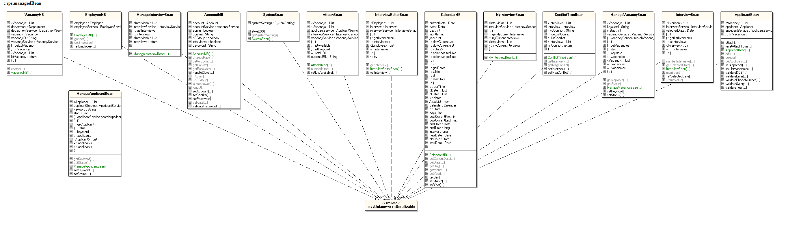

Figure 4.2.3 Managed Bean Class Diagram

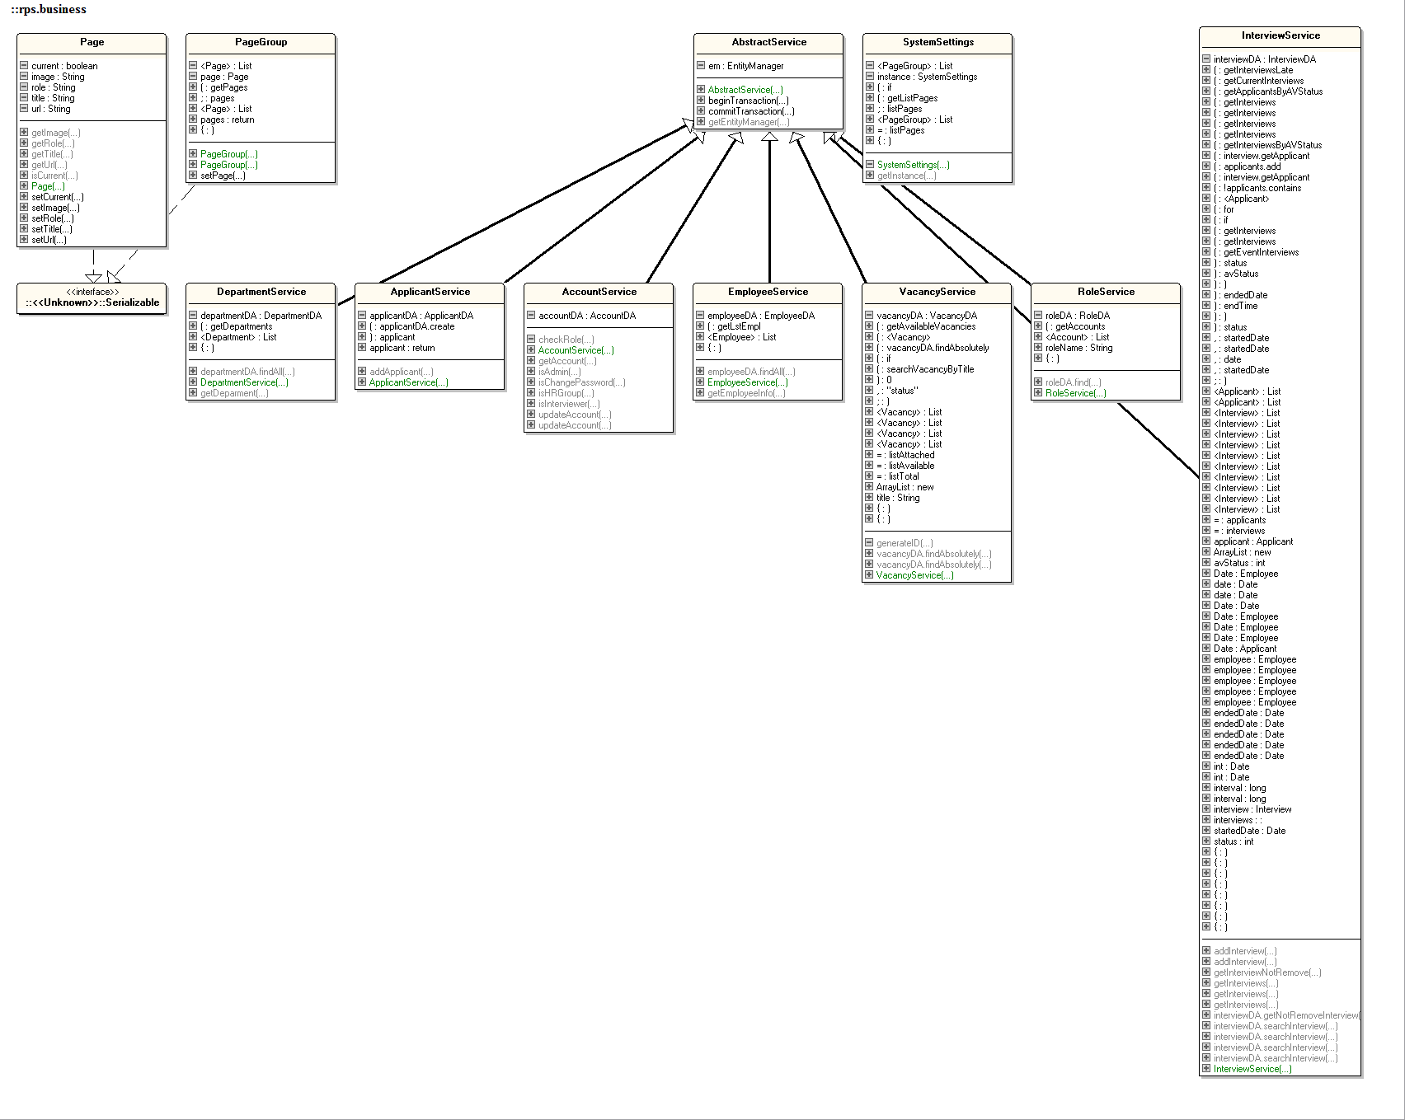

Figure 4.2.4 Business Class Diagram

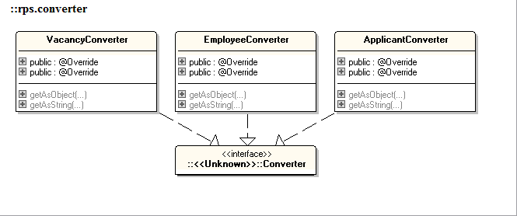

Figure 4.2.5 Converter Class Diagram

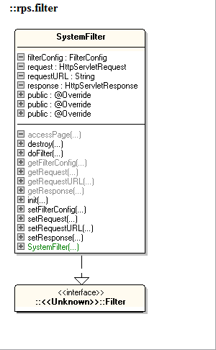

Figure 4.2.1 Filter Class Diagram

## Entity Relationship Diagram

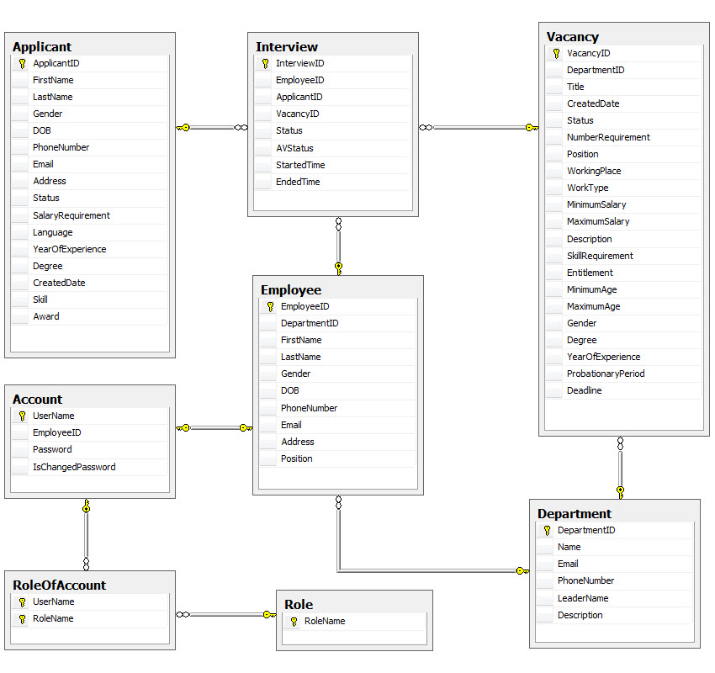

## Database Design

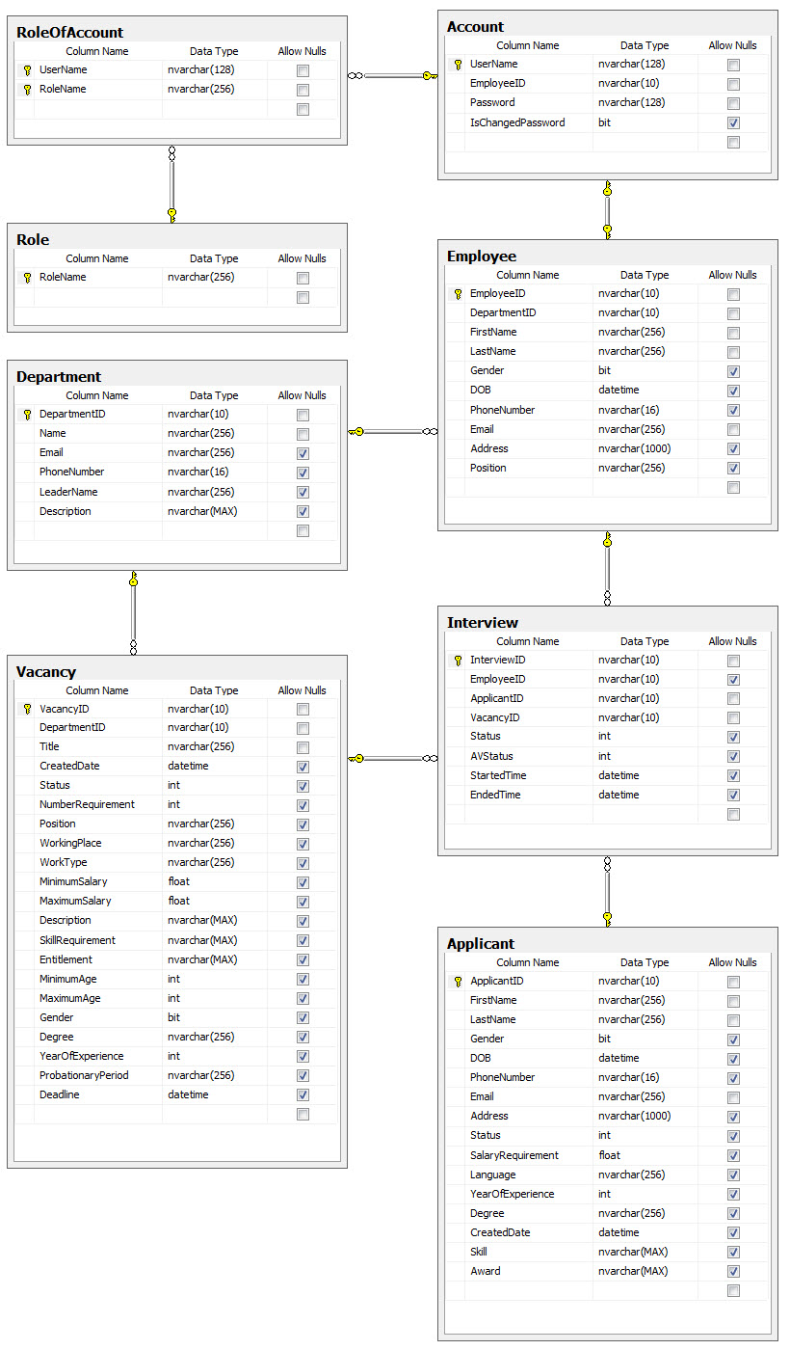

# System Prototype

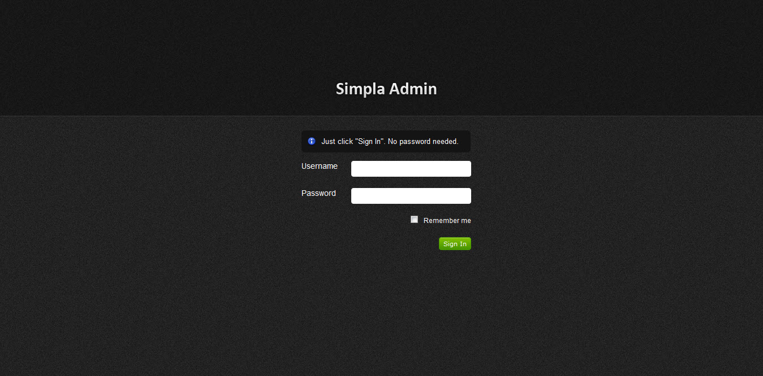

Figure 5.1 Login UI

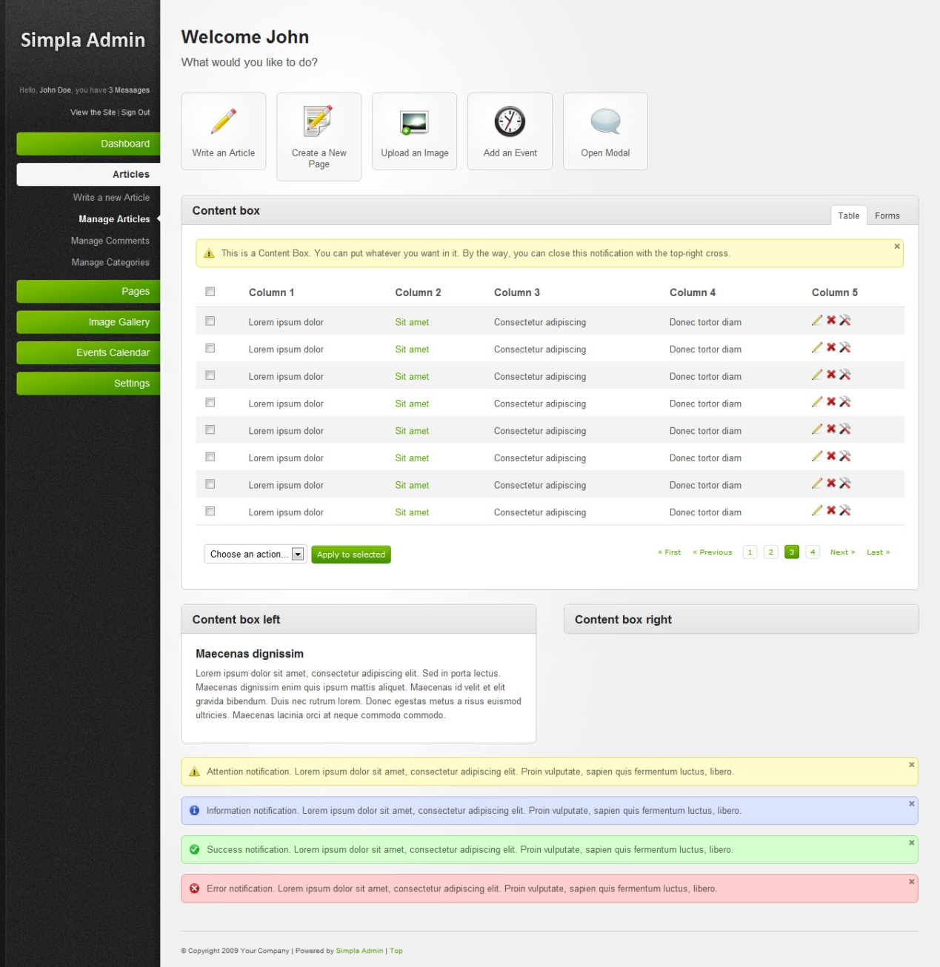

Figure 5.2 Table UI

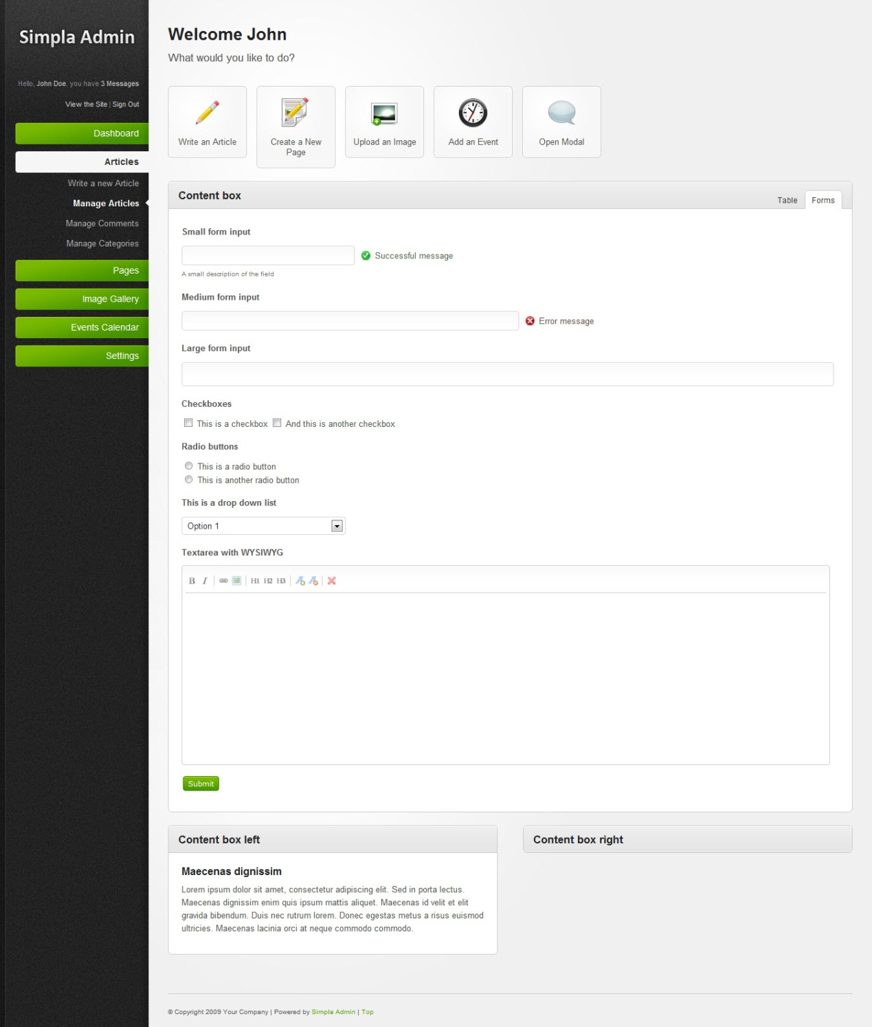

Figure 5.3 Form UI

# Management and Project Planning

## Management Approach

Our team chose the waterfall model management approach and we self-managed

## Task Sheet

|  |  |  |  |
| --- | --- | --- | --- |
| **ID** | **Task** | **Responsible** | **Status** |
| 1 | Login into the system | Hoang Do Phu | Completed |
| 2 | See my detail | Hoang Do Phu | Completed |
| 3 | Create a new vacancy | Tung Trinh Minh | Completed |
| 4 | Create a new applicant | Hoang Do Phu | Completed |
| 5 | Search on Applicant ID and Vacancy ID | Luong Bach Van | Completed |
| 6 | Attach an applicant to a vacancy | Hoang Do Phu | Completed |
| 7 | Schedule the interview | Hoang Do Phu | Completed |
| 8 | View all interviewers schedule | Hoang Do Phu | Completed |
| 9 | View my schedule | Hoang Do Phu | Completed |
| 10 | View details of the vacancies | Luong Bach Van | Completed |
| 11 | View details of applicants | Luong Bach Van | Completed |
| 12 | Search on interview date | Hoang Do Phu | Completed |
| 13 | Change the interview status | Hoang Do Phu | Completed |
| 14 | Edit details for the vacancy | Tung Trinh Minh | Completed |
| 15 | Edit details for the applicant | Hoang Do Phu | Completed |
| 16 | Postpone or remove the interview | Hoang Do Phu | Completed |
| 17 | view reports | Hoang Do Phu | In Progress |
| 18 | reset password for employee |  | Not Started |
| 19 | create a new department |  | Not Started |
| 20 | create a new employee |  | Not Started |
| 21 | attach role for employee |  | Not Started |

# Screenshots

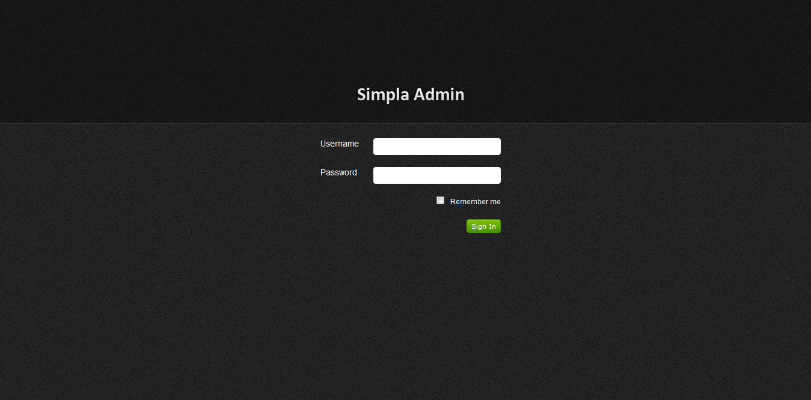

Figure 7.1 Login UI

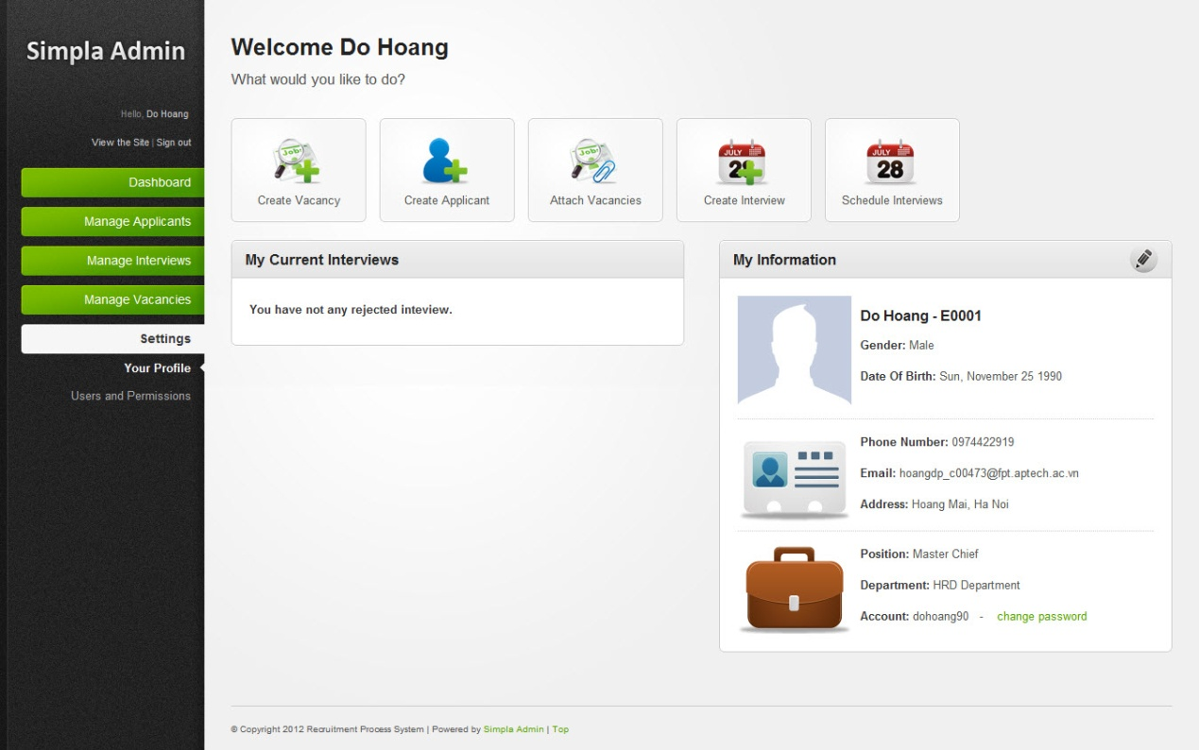

Figure 7.2 Information UI

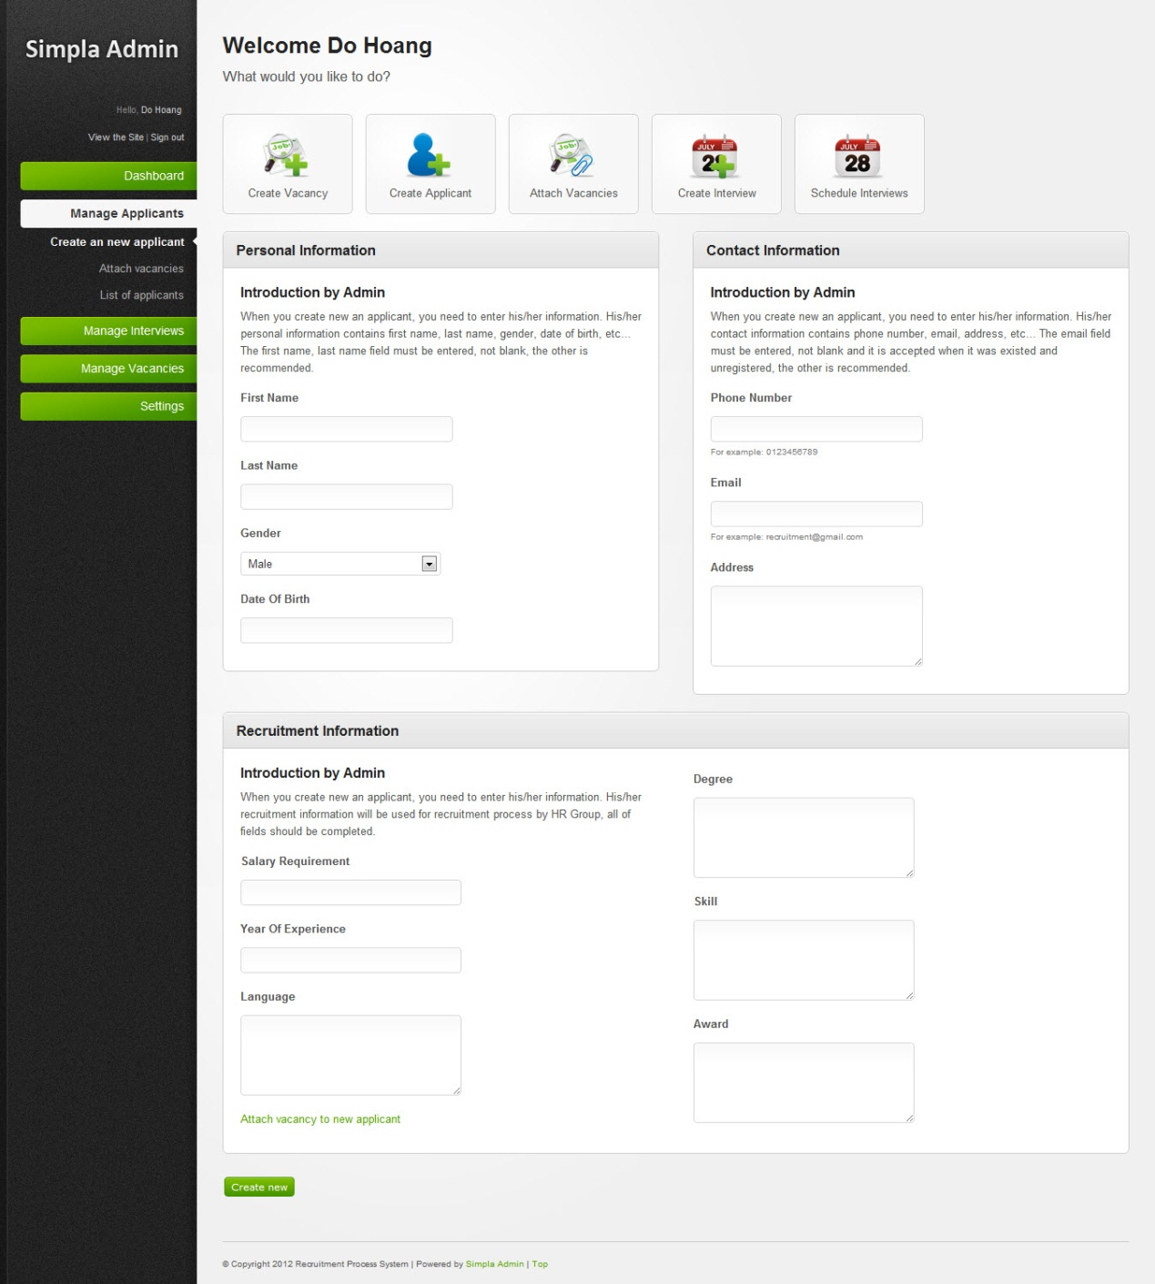

Figure 7.3 Create Applicant UI

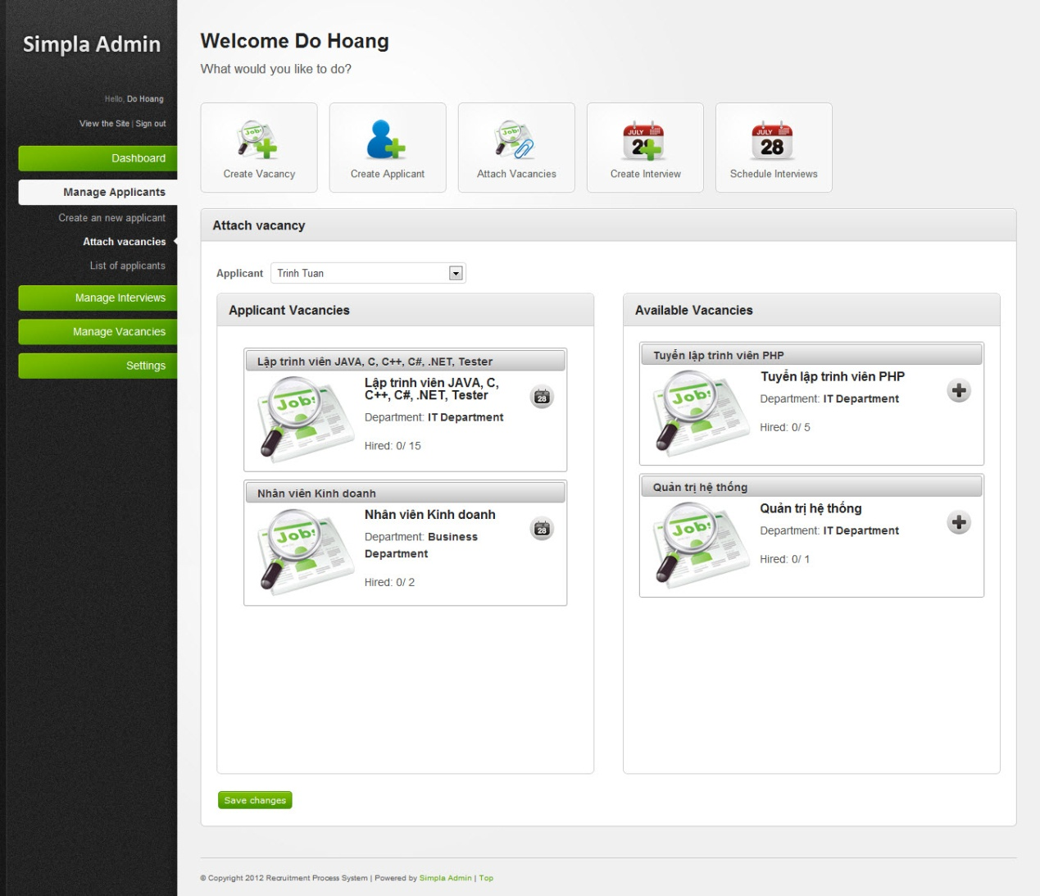

Figure 7.4 Attach Vacancies UI

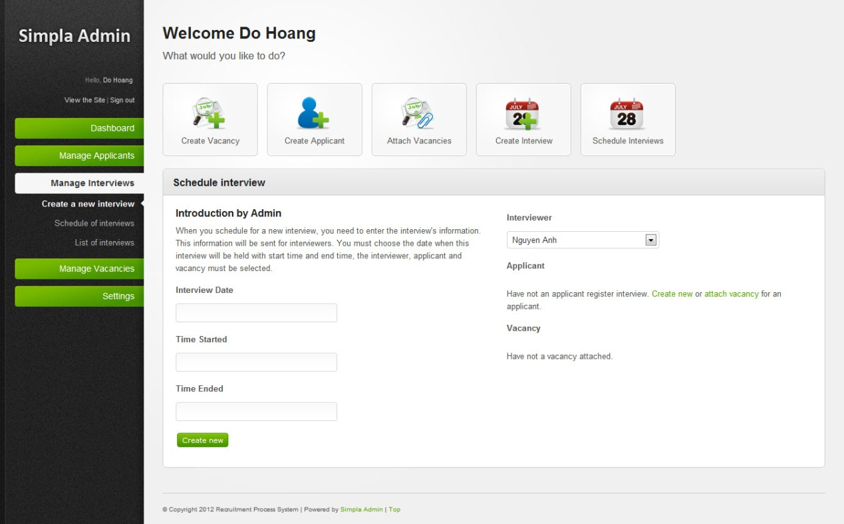

Figure 7.5 Create Interview UI

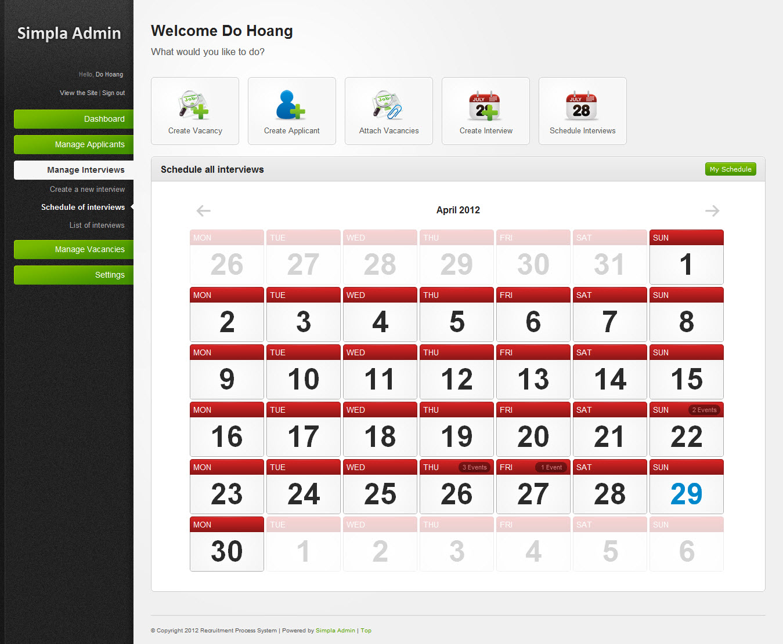

Figure 7.6 All Interview Schedules UI

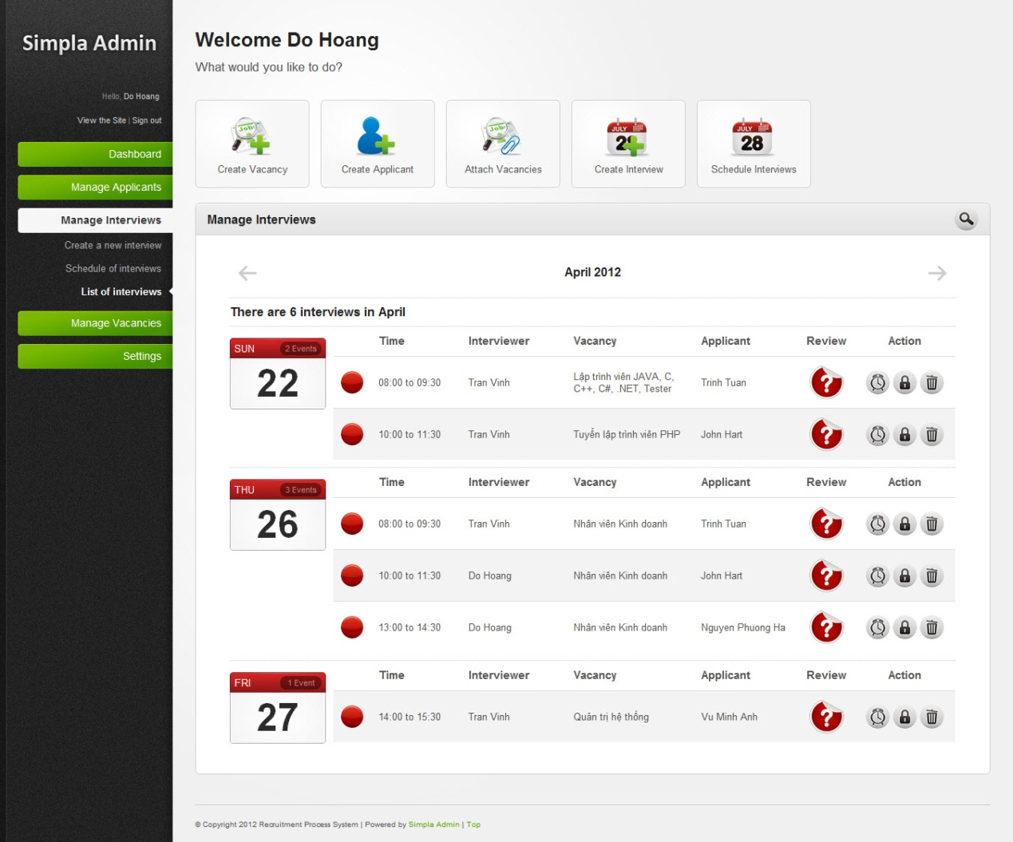

Figure 7.7 Manage Interviews UI

# Coding Convention

# <http://www.oracle.com/technetwork/java/codeconv-138413.html>